### **Discussion Assignment**

Alf Petersen (Entity Relationship Modeling Principles) indicates that a many-to-many relationship is technically impossible to implement because the relationship requires that both entities in the relationship exist before the other. Discuss how a many to many relationship might be resolved for the following relations. As part of your discussion, include the role played by keys.

For this assignment, consider the following entities. Assume that you belong to a family that has more than one automobile and that within the family there is more than one driver. The relationship between these two entities would look like the following:

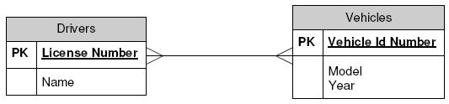

Any driver might be able to drive several vehicles, and several vehicles might be associated with any particular driver. This many-to-many relationship cannot technically exist so it must be resolved.

The following article may provide insight into resolving a many to many relationships between entities: Resolving Many-to-Mary Relationships: <http://www.smartdatacollective.com/19923/>

**Answer:**

**Interesting discussion. I don’t typically think of one person owning more than one car, however I suppose it is possible. Can more than one person be registered to a car? Anyway, won’t worry about those details for the assignment.**

**The solution here is to create another entity that essentially links the vehicle and the person. This entity would be unique and only exist in a one to one ratio with each of vehicle and person (one person cannot own the same car twice, one car paired with a single owner cannot belong to multiple licenses). To make this unique, we need the keys from each of the Driver and Vehicle entity. So the “Ownership”** [**(KarenLopez 2009)**](https://paperpile.com/c/0zGDUS/kSLi) **entity would consist of attributes; Name, License Number, Vehicle ID Number, as an example.**

**References:**

[**KarenLopez. 2009. “Resolving Many-to-Many Relationships - SmartData Collective.” SmartData Collective. July 2, 2009.**](http://paperpile.com/b/0zGDUS/kSLi) [**http://www.smartdatacollective.com/19923/**](http://www.smartdatacollective.com/19923/)[**.**](http://paperpile.com/b/0zGDUS/kSLi)